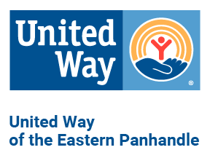
Sample letter/email from your CEO

<Insert Date>

Dear <Insert Employee Name>,

At [company name], we think it’s important for us to do our part to help make the Eastern Panhandle a great place to live and work. That’s why [company name] is a proud supporter of United Way of the Eastern Panhandle. In the next few weeks, you will have the opportunity to support United Way through the United Way Community Campaign.
The United Way Community Campaign helps to provide critical resources in education, income, health and basic needs to the people and families that need them the most. If you have supported the campaign in the past, you know that it’s an easy way to give to our community. With one gift to United Way, you will touch the lives of many individuals and families.
We will be kicking off our United Way workplace campaign on <insert date>. Please consider an investment in your community through United Way as your part in making our community a better place to live. Your investment amount is a personal decision, and any amount is appreciated. Keep in mind that we allow you to spread your gift throughout the year with the convenient option of payroll deduction. (IF APPLICABLE) We also match your gift, so everything you give goes further!
I invite you to join me in giving locally by supporting United Way of the Eastern Panhandle. Together, we are making change happen and building a stronger community!

Sincerely,
[Leadership Name]

