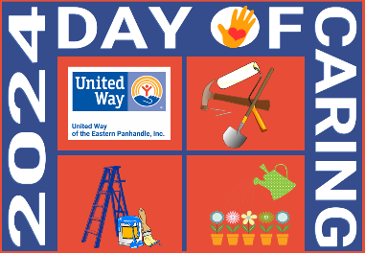
UNITED WAY OF THE EASTERN PANHANDLE

SEPTEMBER 10, 2024 DAY OF CARING

PROJECT FORM

PROJECT FORMS MUST BE SUBMITTED BY FRIDAY, JULY 5th, 2024

Name of Organization_____________________________________________________________

Name of Contact Person___________________________________ Phone # ________________

Email Address ___________________________________________ Cell # __________________

Alternate Contact Person__________________________________ Phone # ________________

Email Address ___________________________________________ Cell # __________________

Please complete the following for EACH Day of Caring project:

Describe your project in detail, including specific room dimensions, etc. Include attachments and photos if necessary:

Street Address of Project:

Is this project at a private home? _____ Yes ______ No

If this project is at a private home, please provide the homeowner’s name and phone number. NO PROJECT WILL BE CONSIDERED WITHOUT A SIGNED DAY OF CARING CLIENT PERMISSION FORM.

Name of Client ______________________________________________ Phone #_____________

Have you had a carpenter or skilled individual assess the project, determine the need for a building permit, and/or provide a list of construction materials? _____ Yes ______ No

If yes, please provide the individual’s name and phone number:

Name _______________________________________________________ Phone #____________

Do you have volunteers for this project or do you need United Way to help recruit?

_______ We have all the volunteers we need.

_______ We have some volunteers, but need more.

_______ We need volunteers assigned to our project.

If you have volunteers, please list the group, business or organization providing the volunteers:

How many volunteers do you anticipate you need the United Way to help recruit? ___________

If you need volunteers with specific skills, please describe:

Organizations are responsible for obtaining the donated materials for their projects, providing lunch for the volunteers assigned to the project, and coordinating trash pickup/cleanup.

If you are unable to provide or find donated materials, please list needed materials:

Please submit this form, along with directions and maps, to:

Penny Porter, CEO / Director of Community Impact
United Way of the Eastern Panhandle
24 District Way, Suite 201
Martinsburg, WV 25404
304-263-0603 Ext. 124 (Office)
304-263-0614 (Fax)
pporter@uwayep.org

All forms are available on our website at www.uwayep.org. Follow the link to “Day of Caring.”

